College Student Management System
Level 1: Very Basic
- Display all students. 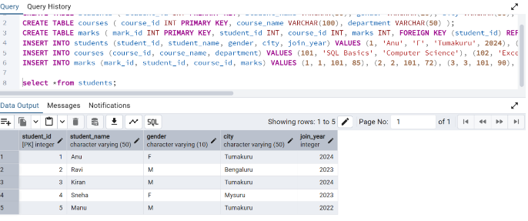

- Display only student_name and city from students table.
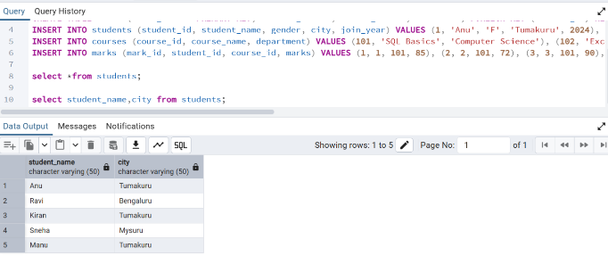

- Show all courses. 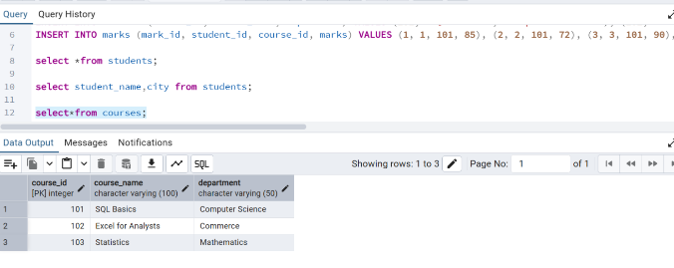

- Display students who are from Tumakuru. 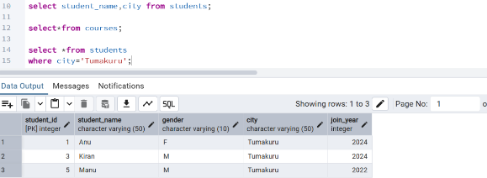

- Display students who joined in 2024. 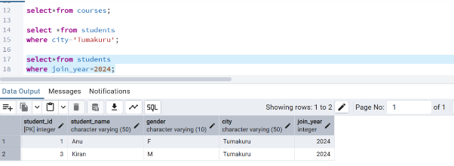

Level 2: Filtering
- Show students whose gender is F.
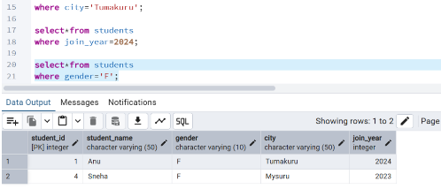

- Show marks greater than 80. 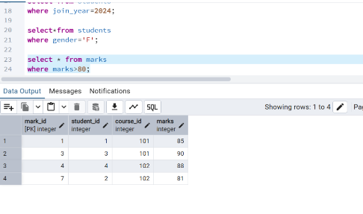

- Display course names from Commerce department.
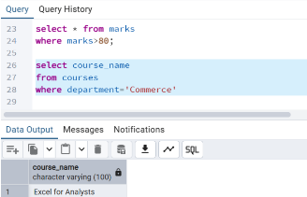

- Show students who are not from Bengaluru. 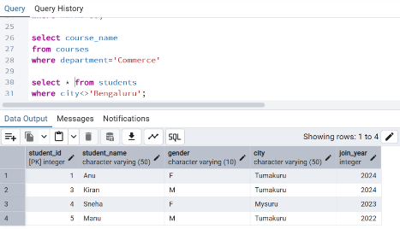

- Display marks between 70 and 90. 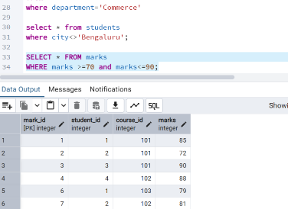

Level 3: Sorting
- Display all students ordered by student_name ascending.
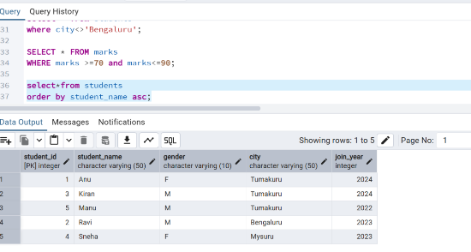
- Show marks ordered from highest to lowest.
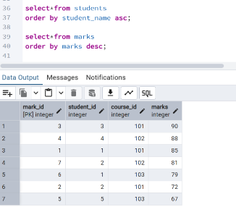

- Display students ordered by join_year descending.
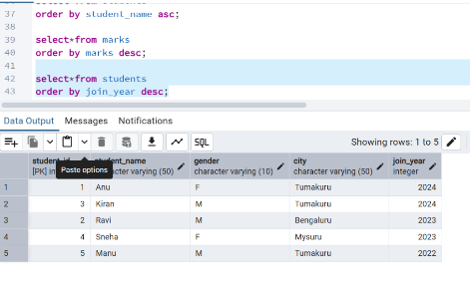
Level 4: Aggregate Basics
- Find total number of students.
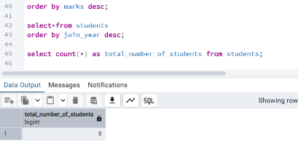

- Find average marks.
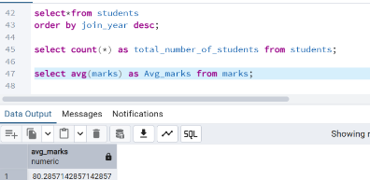

- Find highest marks.
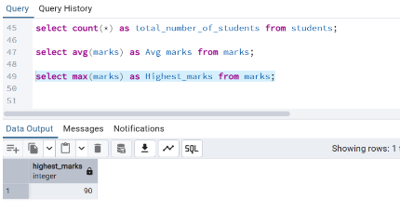

- Find lowest marks.
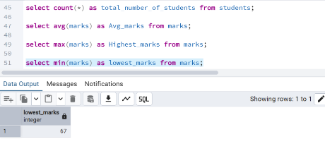

- Find total marks scored by all students.
